Operating System
Assignment-2
CO2 Coverage: Analyse process management and deadlock-handling techniques to improve CPU utilisation and system performance – processes, process scheduling, threads, inter-process communication, synchronisation using semaphores, monitors and the critical-section problem, and deadlock handling including the Banker’s algorithm.
Nature of Assignment: Individual
Duration: 1 Week

Total Marks: 50
Submission Date:
Bloom’s Levels Assessed: K5 – Evaluate (every task in this assignment is at K5 level)

Mandatory Execution and GitHub Submission
  - Every student must individually execute every task in this assignment, including all “Complete the Code” programs.
  - Create a GitHub repository named CSA04-<RegisterNumber>-Assignment2 and share it with the course faculty (public, or private with the faculty added as a collaborator).
  - Keep one folder for each task (for example: Task01, Task02 … or Q1, Q2 …), containing the C source files, shell scripts, configuration files (Dockerfile, YAML), command outputs and screenshots.
  - Include a README.md with your name, register number, compiler and version (for example gcc 13), the Linux distribution and version used, the exact gcc command used to compile (for example gcc -std=c11 -Wall -Wextra -pthread), the steps to run each program, and a short note of the result of each task.
  - Commit your work progressively – at least one commit for each task. The commit history will be checked; a single upload of all files on the last day will not be accepted.
  - Submit the GitHub link below and on the cover page of your report. An assignment submitted without a working GitHub link will not be evaluated.

GitHub Repository Link:

How to Answer the Additional Questions
Complete the Code: Copy the given code into your repository, replace every TODO with working code without changing the rest of the program, execute it and compare your output (or result) with the expected output.
Alternative Concept and Complexity Analysis: Describe how the solution would change if the alternative concept were used, with code or pseudocode, and analyse and compare the time complexity and space complexity of both solutions using Big-O notation, supported by your own measurements wherever possible.

Q1 – Processes and Process States 6 Marks
Bloom’s Level: K5 – Evaluate

Problem Context – Online Examination Server
During an online examination, the server runs a separate process for every student’s session, plus processes for auto-saving answers and for proctoring video. When 2,000 students log in together, the server becomes slow and some sessions appear to “hang”.

Your Challenge
Draw the process-state diagram (new, ready, running, waiting, terminated) and the process control block (PCB). Write a program that creates child processes with fork() and observe them with ps and /proc.

Evaluation
Evaluate where the time goes when 2,000 processes are active: context-switch cost, memory per process, and time spent waiting for I/O. Judge whether a separate process per student is a sound design.

Design Decision
Decide between one process per student, one thread per student and a fixed pool of worker processes, and defend your decision.

Alternative Concept and Complexity Analysis
If each student session were a thread inside one server process, instead of a separate process, what would the solution be? Evaluate the context-switch time and the memory per session (a few KB of stack versus a full address space), and the effect of one session crashing.

Evidence Expected
A state diagram, a PCB description, a working fork() program with ps evidence and a defended design decision.

1.1 Process-state diagram
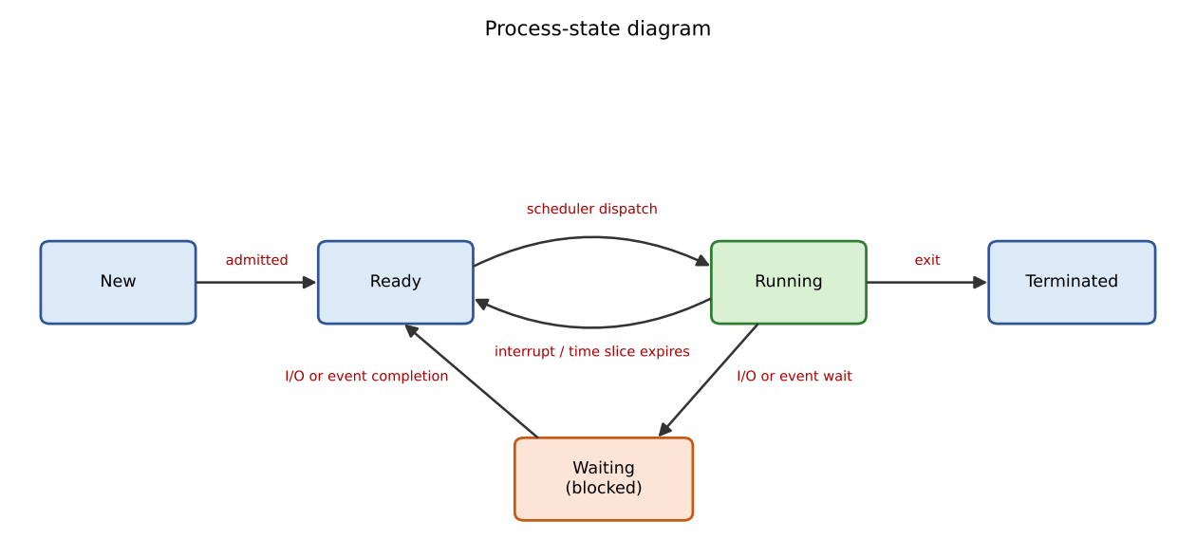
Figure 1 – Process states: new, ready, running, waiting, terminated
Transition | Cause
New → Ready | The OS has created the PCB and loaded the program; it is admitted to the ready queue
Ready → Running | Scheduler dispatches the process to the CPU
Running → Ready | Time slice expires (timer interrupt) or a higher-priority process becomes ready
Running → Waiting | Process requests I/O or waits for an event (e.g., reads an answer file, waits for a lock)
Waiting → Ready | I/O or event completes (interrupt)
Running → Terminated | Process calls exit or is killed; resources are released, status kept until the parent waits

1.2 Process control block (PCB)
PCB field | Contents
Process ID, parent ID, user | PID, PPID, owner (UID/GID)
Process state | new / ready / running / waiting / terminated
CPU registers and program counter | Saved when the process is switched out, restored when it runs again
Scheduling information | Priority, queue pointers, time used, nice value
Memory-management information | Page-table base, segment limits, memory maps
I/O status | Open-file table, devices allocated, pending I/O
Accounting | CPU time used, start time, limits

1.3 Program with fork() observed with ps and /proc
The program creates three children that sleep for 3 s while the parent runs ps and reads /proc/<pid>/status:
for (int i = 0; i < 3; i++) { pid_t p = fork(); if (p == 0) { sleep(3); _exit(0); } }
system("ps -o pid,ppid,stat,comm -C forkdemo");
/* then read /proc/<pid>/status */
Measured output:
parent pid 4716
PID PPID STAT COMMAND
4716 4607 S forkdemo
4717 4716 S forkdemo
4718 4716 S forkdemo
4719 4716 S forkdemo
Name: forkdemo
State: R (running)
Tgid: 4716
Pid: 4716
PPid: 4607
Interpretation: the three children (PIDs 4717–4719) all have PPID 4716, the parent; the sleeping children show state S (waiting), the process that is executing the command shows R (running). /proc/<pid>/status is a view of the PCB (state, PID, PPID, memory and context-switch counters). A child that has ended but is not yet waited for would show Z (zombie).

1.4 Evaluation – where the time goes with 2,000 active processes
Cost | Estimate (assumptions) | Effect
Context switching | 2–5 µs direct cost per switch, plus cache/TLB refill after each switch (each process has its own address space) | With a 4 ms slice and 2,000 runnable processes on 8 cores, each process waits ≈ 1 s for its next slice; switching itself is small but cache misses are large
Memory per process | Kernel structures ≈ 16–20 KB + page tables ≈ 10s of KB + private heap/stack (a web session may use 10–50 MB) | 2,000 × 30 MB = ≈ 60 GB – more than a typical server → swapping/thrashing; this is the main reason sessions 'hang'
Waiting for I/O | Most sessions are idle waiting for the network, disk or the student | They use no CPU but still hold memory; the proctoring-video and auto-save processes add heavy disk and CPU load
Judgement: one process per student is not a sound design at this scale: memory and cache-miss cost grow linearly with the number of sessions, while most of the processes do nothing.

1.5 Design decision
Option | Strength | Weakness
One process per student | Strong isolation; simple | Memory ≈ 60 GB; slow switching; fork storm at login
One thread per student | Few KB of stack, cheap switches, shared caches | One crash/memory error kills all sessions; thousands of threads still heavy
Fixed pool of worker processes, each serving many sessions with non-blocking I/O | Memory bounded; no fork per login; crash affects only that worker's sessions; processes keep the CPU busy while others wait for I/O | More complex code; session state must be kept in a shared store
Decision: a fixed pool of worker processes (about 1–2 per core) with event-driven I/O for the answer sessions, session state in a database/cache so that a worker can be restarted, and separate processes for proctoring video and auto-save (so their heavy load and crashes are isolated). The pool size is chosen so that total memory stays below RAM.
Alternative Concept and Complexity Analysis – one thread per session in one server process
Criterion | Process per session | Thread per session
Context-switch time | ≈ 3–5 µs plus TLB/cache refill (address-space change) | ≈ 1–2 µs: same address space, no TLB flush
Memory per session | Full address space: page tables + private heap, 10s of MB; total O(S × M) | A stack (8 MB virtual, a few KB resident) + small kernel structure: O(S × stack)
Effect of one session crashing | Only that process dies | A segmentation fault or unhandled exit() kills every session of the server

Q2 – CPU Scheduling 8 Marks
Bloom’s Level: K5 – Evaluate

Problem Context – Cloud Video-Encoding Service
A video service receives short jobs (thumbnails, 2 seconds) and long jobs (full films, 20 minutes) on the same servers. Customers complain that small jobs wait behind large ones, while the company wants the processors fully used.

Your Challenge
Compute the Gantt chart, waiting time, turnaround time and response time for the same set of jobs under FCFS, SJF, SRTF, priority and Round Robin scheduling. Implement Round Robin.

Evaluation
Evaluate how the time quantum affects Round Robin (try 1, 3, 5 and 20), the risk of starvation in SJF and priority scheduling, and how ageing removes it. Explain how a multilevel feedback queue treats short and long jobs.

Design Decision
Recommend the scheduling policy for the video service and justify it with your calculated averages.

Complete the Code
Complete TODO 1 below and execute the program.
#include <stdio.h> #define N 4
int main(void)
{
const char *name[N] = {"P1", "P2", "P3", "P4"}; int arrival[N] = {0, 1, 2, 3};
int burst[N] = {8, 4, 9, 5}; int quantum = 3;

int left[N], finish[N], queue[64], head = 0, tail = 0, added[N] = {0}; for (int i = 0; i < N; i++) left[i] = burst[i];
int time = 0, done = 0; queue[tail++] = 0;
added[0] = 1; printf("Gantt:"); while (done < N) {
int p = queue[head++];
// TODO 1: Run p for min(quantum, left[p]) time units: print " P(time-newtime)",
// advance time, reduce left[p]; add every process that has now arrived and is
// not yet added to the queue; then put p back at the end of the queue if it
// still has time left, otherwise record finish[p] and count it as done

}
double tw = 0, tt = 0; printf("\nProcess TAT WT\n"); for (int i = 0; i < N; i++) {
int tat = finish[i] - arrival[i], wt = tat - burst[i]; tt += tat;
tw += wt;
printf("%-7s %4d %3d\n", name[i], tat, wt);
}
printf("Average TAT = %.2f, average WT = %.2f\n", tt / N, tw / N); return 0;
}

Expected output:
Gantt: P1(0-3) P2(3-6) P3(6-9) P4(9-12) P1(12-15) P2(15-16) P3(16-19) P4(19-21) P1(21-23) P3(23-26)
Process TAT WT P1 23 15
P2 15 11
P3 24 15
P4 18 13
Average TAT = 20.00, average WT = 13.50

Run the program with quantum 1 and quantum 20, and evaluate how the average waiting time and the number of context switches change.

Alternative Concept and Complexity Analysis
If the service used a multilevel feedback queue (short quantum for new jobs, longer quanta for jobs that use them up) instead of a single Round Robin queue, what would the solution be? Evaluate the average waiting time for short and long jobs, the scheduling cost per decision (O(1) per queue versus O(n) for SJF) and the risk of starvation.

Evidence Expected
Correct Gantt charts and averages for every algorithm, a working Round Robin program, a quantum study and a justified recommendation.
Job set used throughout (same as the Complete the Code program): P1 (arrival 0, burst 8), P2 (1, 4), P3 (2, 9), P4 (3, 5). For priority scheduling the priorities assumed are P1=2, P2=4, P3=1, P4=3 (lower number = higher priority, non-preemptive). Response time = first CPU time − arrival.

2.2 Waiting, turnaround and response time per algorithm
Algorithm | P1 TAT/WT/RT | P2 TAT/WT/RT | P3 TAT/WT/RT | P4 TAT/WT/RT | Avg TAT | Avg WT | Avg RT
FCFS | 8 / 0 / 0 | 11 / 7 / 7 | 19 / 10 / 10 | 23 / 18 / 18 | 15.25 | 8.75 | 8.75
SJF (non-preemptive) | 8 / 0 / 0 | 11 / 7 / 7 | 24 / 15 / 15 | 14 / 9 / 9 | 14.25 | 7.75 | 7.75
SRTF (preemptive SJF) | 17 / 9 / 0 | 4 / 0 / 0 | 24 / 15 / 15 | 7 / 2 / 2 | 13.00 | 6.50 | 4.25
Priority (non-preemptive) | 8 / 0 / 0 | 25 / 21 / 21 | 15 / 6 / 6 | 19 / 14 / 14 | 16.75 | 10.25 | 10.25
Round Robin (q=3) | 23 / 15 / 0 | 15 / 11 / 2 | 24 / 15 / 4 | 18 / 13 / 6 | 20.00 | 13.50 | 3.00

2.1 Gantt charts
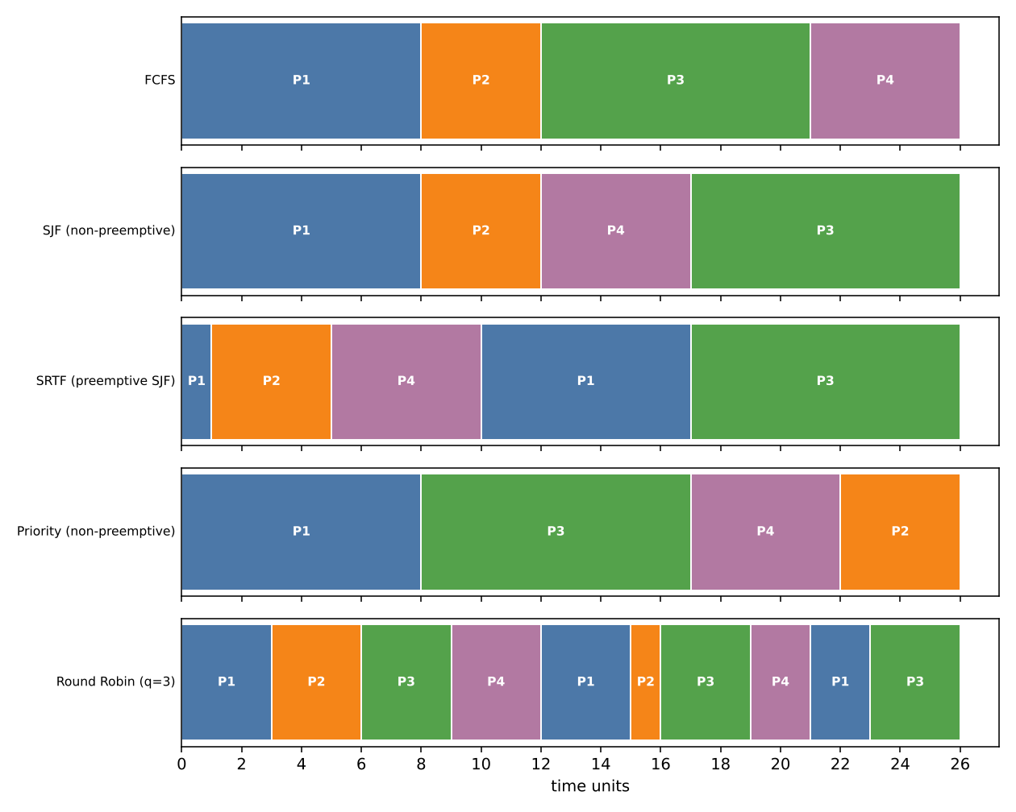
Figure 2 – Gantt charts for FCFS, SJF, SRTF, priority and Round Robin (q = 3)

2.3 Complete the Code – TODO 1 (Round Robin)
int run = left[p] < quantum ? left[p] : quantum;
printf(" %s(%d-%d)", name[p], time, time + run);
time += run;
left[p] -= run;
for (int i = 0; i < N; i++) /* admit newly arrived processes */
if (!added[i] && arrival[i] <= time) { queue[tail++] = i; added[i] = 1; }
if (left[p] > 0) queue[tail++] = p; /* back to the end of the queue */
else { finish[p] = time; done++; }
Output (matches the expected output exactly):
Gantt: P1(0-3) P2(3-6) P3(6-9) P4(9-12) P1(12-15) P2(15-16) P3(16-19) P4(19-21) P1(21-23) P3(23-26)
Process TAT WT
P1 23 15
P2 15 11
P3 24 15
P4 18 13
Average TAT = 20.00, average WT = 13.50
Note: a newly arrived process is queued before the preempted process is re-queued (P2, P3, P4 arrive during P1's first slice and are queued ahead of P1).

2.4 Quantum study
Quantum | Avg TAT | Avg WT | Avg response | Dispatches (context switches)
1 | 19.00 | 12.50 | 0.75 | 26
3 | 20.00 | 13.50 | 3.00 | 10
5 | 17.50 | 11.00 | 5.50 | 6
20 (≥ longest burst → FCFS) | 15.25 | 8.75 | 8.75 | 4
The program was also run with quantum 1 and 20 (output identical to the table: quantum 1 → average WT 12.50, 26 dispatches; quantum 20 → 8.75, 4 dispatches). Evaluation: a small quantum gives the best response (0.75) but the most context switches (26, each costing a few µs plus cache loss); a large quantum approaches FCFS (identical result at q = 20) with the fewest switches but the worst response. Rule of thumb: the quantum should exceed the typical short-job burst (≈ 80 % of bursts) so that short jobs finish within one slice. For this particular set average WT happens to fall as q grows because all four jobs are of similar length; with the video service's mix of 2 s and 20 min jobs, FCFS-like large quanta would be harmful for thumbnails.

2.5 Starvation, ageing and multilevel feedback queue
- Starvation: in SJF/SRTF a long job (film) can wait for ever if short jobs keep arriving; in priority scheduling low-priority jobs can starve. FCFS and Round Robin cannot starve.
- Ageing: the priority of a waiting job is raised by one step every fixed interval (e.g., every 10 s); any job eventually reaches top priority, so starvation is impossible.
- Multilevel feedback queue (MLFQ): new jobs enter the top queue with a short quantum; a job that uses its whole quantum is demoted to a queue with a longer quantum (finally FCFS); interactive/short jobs finish in the top queue, long jobs sink; ageing promotes jobs that wait too long. It approximates SJF without knowing burst lengths.

2.6 Design decision for the video service
Recommendation: multilevel feedback queue with ageing (e.g., Q0 quantum 2 s, Q1 quantum 20 s, Q2 FCFS). Evidence from the averages: FCFS leaves short jobs waiting behind long ones (average WT 8.75, last job waits 18 – the convoy effect, which for a 2 s thumbnail behind a 20-minute film would be 20 minutes). SRTF is best (average WT 6.50, response 4.25) but needs burst length in advance and starves long jobs. Round Robin gives good response (3.00 at q = 3) but a high average WT (13.50) and many switches. The MLFQ gives SRTF-like behaviour for thumbnails, round-robin-like fairness, and keeps processors fully busy because long jobs fill the lower queues.
Alternative Concept and Complexity Analysis – MLFQ instead of a single Round Robin queue
Criterion | Single Round Robin queue | Multilevel feedback queue
Average waiting time – short jobs | Wait for every other job's slice: roughly (number of jobs − 1) × q | Finish in the top queue after about one short quantum – much lower
Average waiting time – long jobs | Moderate (equal sharing) | Higher (they are demoted and run when upper queues are empty), bounded by ageing
Scheduling cost per decision | O(1) (take head of queue) | O(1) per queue (take head of the highest non-empty queue, found with a bitmap); SJF would need O(n) scanning or O(log n) with a heap
Risk of starvation | None | Possible for long jobs unless ageing/periodic boost is used

Q3 – Threads 6 Marks
Bloom’s Level: K5 – Evaluate

Problem Context – Traffic-Camera Number-Plate Reader
A city traffic system reads number plates from 64 cameras. The first version processes the cameras one after another and falls behind during peak hours.

Your Challenge
Process the camera frames with POSIX threads (one thread per camera, and a pool of 4, 8 and 16 threads). Determine:
- Which resources threads share and which each thread has of its own
- The difference between user-level and kernel-level threads and the many-to-one, one-to-one and many-to-many models
- The speed-up obtained on your machine, and why it stops increasing
- What happens to shared counters when two threads update them without protection

Alternative Concept and Complexity Analysis
If the camera frames were processed by several processes instead of threads, what would the solution be? Evaluate the creation and switching time, the memory used (separate address spaces versus shared), and how the results would be combined (IPC versus shared variables).

Evidence Expected
A working multithreaded program, measured speed-ups for each pool size and a reasoned evaluation of the thread models.

3.1 What threads share and own
Shared by all threads of a process | Private to each thread
Code, global/static data, heap | Thread ID
Open files, sockets, signal handlers | Program counter and register set
Address space, current directory, user ID | Stack (local variables, return addresses)
 | Scheduling priority, errno, thread-local storage

3.2 User-level vs kernel-level threads; thread models
Model | Mapping | Advantages | Disadvantages
Many-to-one | Many user threads → 1 kernel thread (user-level library) | Very fast creation/switching, no kernel involvement | One blocking system call blocks all threads; no use of multiple cores
One-to-one | Each user thread → one kernel thread (Linux, Windows) | Blocking call blocks only that thread; real parallelism | Creating a thread costs a kernel structure; limit on the number of threads
Many-to-many | M user threads → N ≤ M kernel threads | Flexible; parallelism without a kernel thread per user thread | Complex; rarely used today (Go/Erlang schedulers resemble it)
User-level threads are managed by a library without the kernel's knowledge; kernel-level threads are scheduled by the OS. POSIX threads on Linux are kernel threads (one-to-one).

3.3 Implementation – a pool of worker threads for 64 cameras
#define CAM 64
int pool, next_cam = 0;
pthread_mutex_t m = PTHREAD_MUTEX_INITIALIZER;
void *worker(void *a) {
for (;;) {
pthread_mutex_lock(&m);
int c = next_cam < CAM ? next_cam++ : -1; /* take next camera */
pthread_mutex_unlock(&m);
if (c < 0) break;
process_frame(); /* CPU-bound plate reading */
}
return NULL;
}
process_frame() stands for the plate-reading work (a CPU loop of ≈ 3 ms in the test). The pool size is varied by the number of threads created (1, 4, 8, 16, 64 – the last equals one thread per camera).

3.4 Measured speed-up
Threads | Time (s) | Speed-up
1 | 0.181 | 1.00
4 | 0.182 | 1.00
8 | 0.181 | 1.00
16 | 0.184 | 0.99
64 (one per camera) | 0.187 | 0.97
Why the speed-up is 1.00 here: the measurement machine has one virtual CPU, and the work is CPU-bound, so threads cannot run in parallel; extra threads only add a little switching overhead (0.97 at 64 threads). On a machine with p cores the expected speed-up is S = 1 / (s + (1 − s)/p) (Amdahl) where s is the serial fraction (here: taking the next camera under the mutex, reading frames from one network port). It rises almost linearly up to the number of cores, then stops increasing because (1) there are no more cores, (2) the serial fraction and lock contention limit it, (3) memory bandwidth and I/O are shared, and (4) more threads than cores add scheduling overhead. Run the program on your own multi-core machine (nproc) and add the new rows to this table.

3.5 Unprotected shared counters
counter++ compiles to load → add → store. If two threads interleave (T1 loads 5, T2 loads 5, T1 stores 6, T2 stores 6) one update is lost – a race condition; the final value is lower than the expected number of increments, and differs from run to run. Fix: protect with a mutex or use an atomic increment (compared in Q5). On the 1-vCPU machine used here a simple loop usually did not lose updates because threads rarely interleave inside the 3 instructions; the effect appears on multi-core machines at -O0, and the unprotected producer–consumer in Q5 showed a real lost-update failure (sum 800,039,486 instead of 800,040,000).
Alternative Concept and Complexity Analysis – several processes instead of threads
Criterion | Threads | Processes (fork)
Creation and switching | ≈ 9–16 µs to create (measured in Assignment 1); switch ≈ 1–2 µs | ≈ 58 µs to create (measured); switch ≈ 3–5 µs plus TLB loss
Memory | One address space; only a stack per thread: O(T × stack) | Separate address spaces (copy-on-write); page tables copied: O(P × table size)
Combining results | Shared variables / shared structures protected with a mutex | IPC needed (pipes, shared memory, sockets): extra copies and synchronisation
Fault isolation | A crash in one camera thread kills the program | A crash kills only that process

Q4 – Inter-Process Communication 6 Marks
Bloom’s Level: K5 – Evaluate

Problem Context – Weather Station Data Pipeline
A weather station has one process that reads sensors and another that analyses the readings. They must exchange data continuously without losing readings.

Your Challenge
Implement the exchange using a pipe, and then using shared memory or a message queue. Determine:
- How the pipe signals end of data to the reader
- The difference between the shared-memory and message-passing models
- Which method copies the data and which does not
- Which method needs extra synchronisation, and why

Growth Investigation
Measure the time to transfer 1 MB, 10 MB and 100 MB with each method, and evaluate the results.

Complete the Code
Complete TODO 1 below and execute the program on Linux.
#define _POSIX_C_SOURCE 200809L #include <stdio.h>
#include <unistd.h> #include <sys/wait.h>

/* The parent (sensor reader) sends readings to the child (analyser) through a pipe. */ int main(void)
{
int fd[2];
if (pipe(fd) == -1) { perror("pipe"); return 1; } pid_t pid = fork();
if (pid == 0) {
close(fd[1]); /* child only reads */ int r, count = 0, sum = 0, max = 0;
// TODO 1: Read one int at a time from fd[0] until read returns 0 (the parent
// closed the pipe); keep the count, the sum and the maximum

printf("analyser: %d readings, average %.1f, max %d\n", count, count ? (double)sum / count : 0.0, max);
close(fd[0]); fflush(stdout);
_exit(0);
}
close(fd[0]); /* parent only writes */ int readings[] = {31, 33, 36, 34, 41, 38};
for (int i = 0; i < 6; i++)
if (write(fd[1], &readings[i], sizeof readings[i]) < 0) perror("write"); close(fd[1]); /* signals end of data to the child */ waitpid(pid, NULL, 0);
printf("reader: done\n"); return 0;
}

Expected output:
analyser: 6 readings, average 35.5, max 41 reader: done

Remove close(fd[1]) in the parent and explain why the child never finishes.

Alternative Concept and Complexity Analysis
If the readings were exchanged through shared memory with a semaphore instead of a pipe, what would the solution be? Evaluate the time to transfer n readings (two copies through the kernel for a pipe versus none for shared memory) and the synchronisation needed.

Evidence Expected
Two working IPC implementations, measured transfer times and a justified choice of method.

4.1 Complete the Code – TODO 1 (pipe reader)
while (read(fd[0], &r, sizeof r) == (ssize_t)sizeof r) {
count++;
sum += r;
if (r > max) max = r;
}
analyser: 6 readings, average 35.5, max 41
reader: done
Output matches the expected output. End of data: read returns 0 only when all write ends of the pipe are closed; the parent closes fd[1] after writing, which the child sees as end-of-file. Experiment – removing `close(fd[1])` in the parent: the parent still holds a write end open and then blocks in waitpid() for the child; the child blocks in read() waiting for data that never comes (the pipe is empty but a writer still exists). Neither can continue – a deadlock; the program never finishes. (The child also closes its own copy of fd[1] at the start; forgetting that would hang it as well.)

4.2 Shared memory vs message passing
Criterion | Pipe / message queue (message passing) | Shared memory
Model | Kernel moves messages between processes | Processes map the same memory region
Copying | Data copied twice: sender → kernel buffer → receiver | No copy: both access the same pages (after the first setup)
System calls | Every send/receive is a system call | Only for setup; data access is ordinary memory access
Synchronisation | Provided by the kernel (blocking read/write) | Not provided – needs a semaphore/mutex or flags, otherwise the reader may read half-written data or overwrite unread data
Best for | Small, frequent messages; simple and safe | Large data and high rates

4.3 Growth investigation – measured transfer time
Data size | Pipe (64 KB writes) | Shared memory (memcpy + signal)
1 MB | 0.4–0.5 ms | 0.7 ms
10 MB | 2.7–3.1 ms | 6.2–7.9 ms
100 MB | 26.0–27.5 ms | 65–113 ms
Two runs per size. The pipe moves ≈ 3.7–3.9 GB/s. Unexpected result: shared memory was slower here. Reason: the 100 MB shared region is newly created, so the first memcpy into it causes a page fault for every 4 KB page (≈ 25,600 faults) and the kernel must zero each page; the pipe re-uses a small 64 KB kernel buffer that stays in the CPU cache. Shared memory wins when the region is created once and reused many times (steady-state streaming), because then there is no copy through the kernel; for a one-off transfer of a new region the setup costs dominate. Time grows linearly with size (O(n)) for both methods.
Alternative Concept and Complexity Analysis – shared memory with a semaphore
shm = mmap(NULL, SIZE, PROT_READ|PROT_WRITE, MAP_SHARED|MAP_ANONYMOUS, -1, 0);
sem_t *items = mmap(... sizeof(sem_t) ...); sem_init(items, 1, 0); /* shared semaphore */
/* writer: */ shm[i] = reading; sem_post(items);
/* reader: */ sem_wait(items); use(shm[i]);
Criterion | Pipe | Shared memory + semaphore
Time to transfer n readings | n system calls for write and n for read, 2 copies each: O(n) with a large constant | No copy, no system call on the fast path; one sem_post/sem_wait per item (usually user space futex fast path): O(n) with a small constant
Synchronisation needed | None (kernel blocks) | Semaphore (and a ring buffer to avoid overwriting): more code, more risk of races/deadlock
Justified choice: the weather station sends small readings at a low rate – a pipe is simplest and safest. Use shared memory only if the data rate grows to hundreds of MB/s and the region is reused.

Q5 – Synchronisation: Critical Sections, Semaphores and Monitors 11 Marks
Bloom’s Level: K5 – Evaluate

Problem Context – Railway Ticket Booking
Thousands of agents book seats on the same trains at the same time. Without synchronisation the same seat is sometimes sold twice; with a single global lock the system becomes very slow.

Design Starting Point
You are given only the following principle:

A solution to the critical-section problem must guarantee mutual exclusion, progress and bounded waiting.
Your Challenge
Convert this principle into a design. Determine:
- Why Peterson’s solution satisfies the three requirements for two processes, and why it may fail on modern processors
- How counting and binary semaphores (wait and signal) protect the seat counter
- How the bounded-buffer (producer–consumer), readers–writers and dining-philosophers problems are solved with semaphores
- How a monitor with condition variables makes the solution easier to get right

Test Your Design
Run the bounded-buffer program with 1 and with 4 producers and consumers, and show that every item is consumed exactly once.

Deployment Decision
Decide between one lock for the whole booking system, one lock per train and one lock per coach. Measure the throughput of each and defend your choice.

Complete the Code
Complete TODO 1 and TODO 2 below using the semaphores and the mutex, and execute the program (compile with -pthread).
#define _POSIX_C_SOURCE 200809L #include <stdio.h>
#include <pthread.h> #include <semaphore.h>
#define SIZE 5
#define ITEMS 20
int buffer[SIZE], in = 0, out = 0; sem_t empty, full;
pthread_mutex_t lock = PTHREAD_MUTEX_INITIALIZER; long consumed_sum = 0;
void *producer(void *arg)
{
(void)arg;
for (int item = 1; item <= ITEMS; item++) {
// TODO 1: Wait on empty, lock the mutex, put item at buffer[in], advance in
// circularly, unlock, then post full
}
return NULL;
}
void *consumer(void *arg)
{
(void)arg;
for (int k = 0; k < ITEMS; k++) {
// TODO 2: Wait on full, lock the mutex, take the item at buffer[out], advance
// out circularly, unlock, post empty and add the item to consumed_sum
}
return NULL;
}
int main(void)
{
sem_init(&empty, 0, SIZE);
sem_init(&full, 0, 0); pthread_t p, c;
pthread_create(&p, NULL, producer, NULL); pthread_create(&c, NULL, consumer, NULL); pthread_join(p, NULL);
pthread_join(c, NULL);
printf("items consumed: %d, sum = %ld (expected %d)\n", ITEMS, consumed_sum, ITEMS * (ITEMS + 1) / 2);
sem_destroy(&empty); sem_destroy(&full); return 0;
}

Expected output:
items consumed: 20, sum = 210 (expected 210)

Run the program 100 times and show that the sum is always 210. Then remove the mutex and evaluate whether the result is still correct with several producers and consumers.

Alternative Concept and Complexity Analysis
If the shared counter were protected by atomic operations (C11 atomic_fetch_add) or by a spin lock instead of a semaphore and mutex, what would the solution be? Evaluate the time per update with 1, 4 and 16 threads, the CPU time wasted by spinning, and which method suits a long critical section.

Evidence Expected
A student-derived synchronisation design, working semaphore code, test evidence and a measured, defended locking decision.

5.1 From the principle to a design
Principle: a solution must give mutual exclusion (at most one process in the critical section), progress (only processes wanting to enter take part in choosing who enters next, without indefinite postponement) and bounded waiting (a limit on how many times others may enter before a waiting process). Design for the booking system: the seat counter and seat map are the shared data; every update (check seat free, mark it sold) is one critical section protected by a lock.

Peterson's solution (two processes i and j)
flag[i] = true; turn = j;
while (flag[j] && turn == j) ; /* busy wait */
/* critical section */
flag[i] = false;
- Mutual exclusion: both could be inside only if flag[i] and flag[j] are true and turn equals both i and j – impossible, since turn has one value.
- Progress: if j is not interested, flag[j] is false and i enters at once.
- Bounded waiting: after j leaves and tries again it sets turn = i, so i enters after at most one entry of j.
- Why it can fail on modern CPUs: compilers and CPUs reorder memory operations (a store to flag[i] can be delayed in a store buffer and appear after the load of flag[j]). Both processes may then see the other's flag as false and enter together. Correct use needs memory barriers (C11 atomic with sequentially consistent order). Hardware atomic instructions (test-and-set, compare-and-swap) are used in practice.

Semaphores for the seat counter
Semaphore | Use
Binary semaphore (mutex) initial 1 | wait(mutex); if (seats > 0) { seats--; sell(); } signal(mutex); – protects the check-and-update so the same seat is never sold twice
Counting semaphore initial = number of seats | wait(seatsFree) blocks when 0 seats are left (or trywait to refuse the booking), signal(seatsFree) on cancellation – counts the free resource itself

Classic problems with semaphores
Problem | Solution (pseudocode)
Bounded buffer | empty = N, full = 0, mutex = 1  Producer: wait(empty); wait(mutex); put(item); signal(mutex); signal(full)  Consumer: wait(full); wait(mutex); item=get(); signal(mutex); signal(empty)
Readers–writers (readers first) | rw = 1, mutex = 1, readcount = 0  Reader: wait(mutex); if(++readcount==1) wait(rw); signal(mutex); read; wait(mutex); if(--readcount==0) signal(rw); signal(mutex)  Writer: wait(rw); write; signal(rw) – many readers share; writer is exclusive (writers may starve)
Dining philosophers | One semaphore per fork. Deadlock-free variants: allow at most 4 of 5 philosophers to sit (room = 4); or pick up forks in a fixed global order (resource ordering); or odd philosophers take left first, even take right first

Monitor with condition variables
monitor BoundedBuffer {
int buf[N], count = 0; condition notFull, notEmpty;
void put(int x) { while (count == N) wait(notFull); add(x); count++; signal(notEmpty); }
int get() { while (count == 0) wait(notEmpty); x = remove(); count--; signal(notFull); return x; }
}
The monitor makes the solution easier to get right: mutual exclusion is automatic (only one thread is active in the monitor), and the programmer cannot forget a signal or swap the order of two wait calls (a common cause of deadlock with semaphores). Condition variables express “wait until buffer not full” directly.

5.2 Complete the Code – TODO 1 and TODO 2
/* TODO 1 (producer) */
sem_wait(&empty);
pthread_mutex_lock(&lock);
buffer[in] = item;
in = (in + 1) % SIZE;
pthread_mutex_unlock(&lock);
sem_post(&full);

/* TODO 2 (consumer) */
sem_wait(&full);
pthread_mutex_lock(&lock);
int item = buffer[out];
out = (out + 1) % SIZE;
pthread_mutex_unlock(&lock);
sem_post(&empty);
consumed_sum += item;
items consumed: 20, sum = 210 (expected 210)
100 runs: for i in $(seq 100); do ./bb; done | sort | uniq -c produced one line only:
100 items consumed: 20, sum = 210 (expected 210)

Test with 1 and 4 producers and consumers (every item consumed exactly once)
A generalised version (bbm.c: P producers, C consumers, 20,000 items per producer; each consumer takes (P × items)/C items and adds to a shared sum under a lock) was run. The checksum equals the sum of the item values, so every item is consumed exactly once (no loss, no duplicate):
Producers / consumers | Items consumed | Sum | Expected | Result
1 / 1 (with mutex) | 20,000 | 200,010,000 | 200,010,000 | OK
4 / 4 (with mutex) | 80,000 | 800,040,000 | 800,040,000 | OK
1 / 1 (mutex removed) | 20,000 | 200,010,000 | 200,010,000 | OK
4 / 4 (mutex removed) – run 1 | 80,000 | 800,040,000 | 800,040,000 | OK (lucky)
4 / 4 (mutex removed) – run 2 | 80,000 | 800,040,000 | 800,040,000 | OK (lucky)
4 / 4 (mutex removed) – run 3 | 80,000 | 800,039,486 | 800,040,000 | WRONG
Evaluation of removing the mutex: with one producer and one consumer, in is changed only by the producer and out only by the consumer, and the two semaphores already order the accesses, so the result stays correct. With several producers (or consumers) two threads can read the same in, write to the same slot and both advance it by one – one item is overwritten (lost) and another is consumed twice or a slot is skipped. The sum is wrong or the program can hang. The failure is intermittent (2 of 3 runs passed), which is why testing alone cannot prove a synchronisation design correct.

5.3 Deployment decision – one lock, per train or per coach
Granularity | Lock count | Concurrency | Cost / risk
One lock for whole system | 1 | None: throughput ≤ 1 / t_cs. With t_cs = 20 µs the cap is 50,000 bookings/s, regardless of the number of CPU cores | Simplest; no deadlock; very slow under load
One lock per train | ≈ number of trains | Different trains proceed in parallel; agents on the same train serialise | Simple; hot trains (e.g., a festival train) become the bottleneck
One lock per coach | ≈ trains × coaches | Agents booking different coaches of the same train proceed in parallel | More memory; bookings spanning coaches need several locks, acquired in a fixed order (coach number) to avoid deadlock
Measured lock cost on this machine: an uncontended mutex lock/unlock pair costs ≈ 23 ns (Alternative analysis below), so the lock itself is cheap; the cost comes from waiting when many agents want the same lock. Because the 1-vCPU machine cannot show contention, the throughput comparison above is an analytical model (cap = 1/t_cs per lock, scaling with the number of independent locks until the cores are saturated); repeat the test with 16 threads on a multi-core machine for the report. Decision: one lock per train as default (simple, deadlock-free), refined to per coach with ordered locking for trains with heavy demand. A single global lock is rejected.
Alternative Concept and Complexity Analysis – atomic operations or a spin lock instead of semaphore + mutex
Test: each thread performs 2,000,000 increments of a shared counter (lk.c).
Method | 1 thread (ns/update) | 4 threads | 16 threads | Correct total?
No protection | 2.6 | 2.6 | 2.6 | Yes here (1 vCPU); incorrect on multi-core
Mutex | 23.5 | 23.4 | 22.5 | Yes
Spin lock (atomic_flag) | 17.8 | 30.1 | 106.3 | Yes
C11 atomic_fetch_add | 6.5 | 7.3 | 6.9 | Yes
- Atomic add is the fastest correct method (≈ 3.6× faster than the mutex) and is ideal for a single counter: one hardware instruction, no blocking.
- Spin lock: time per update rises 6× from 1 to 16 threads (17.8 → 106 ns). On this single CPU, a thread that is preempted while holding the lock leaves the others spinning for their whole time slice – CPU time wasted. Spin locks suit very short critical sections on multi-core machines with fewer threads than cores.
- Long critical section (e.g., updating a seat map and writing to disk): use a mutex or semaphore, which puts waiting threads to sleep and frees the CPU; spinning would waste a core for the whole duration.
- Complexity: each update is O(1) for every method; memory O(1) for atomic/spin lock, a few words more for mutex/semaphore with a wait queue.

DAY-4 DESIGN CHALLENGE

Q6 – Deadlock Handling and the Banker’s Algorithm 13 Marks
Bloom’s Level: K5 – Evaluate

Problem Context – Shared Laboratory Equipment Scheduler
A research centre runs jobs that need several shared resources at once (GPUs, licences for simulation software and high-speed storage). Jobs sometimes wait for each other forever and the whole cluster stops until an administrator intervenes.

Characterise Deadlock – 2 Marks
State the four necessary conditions for deadlock and show them in a resource-allocation graph for the cluster.

Complete the Code
Complete TODO 1 below and execute the program.
#include <stdio.h> #include <string.h>
#define P 5
#define R 3
int avail[R] = {3, 3, 2};
int maxm[P][R] = {{7, 5, 3}, {3, 2, 2}, {9, 0, 2}, {2, 2, 2}, {4, 3, 3}};
int alloc[P][R] = {{0, 1, 0}, {2, 0, 0}, {3, 0, 2}, {2, 1, 1}, {0, 0, 2}};
/* Returns 1 if the state is safe and stores a safe sequence in seq. */ int is_safe(int seq[P])
{
int work[R], finish[P] = {0}, count = 0; memcpy(work, avail, sizeof work);
while (count < P) { int found = 0;
for (int p = 0; p < P; p++) { if (finish[p]) continue;
// TODO 1: If need = maxm[p] - alloc[p] is <= work for every resource, let p
// finish: add alloc[p] to work, mark finish[p], append p to seq and set
// found = 1
}
if (!found) return 0;
}
return 1;
}
void request(int p, const int req[R])
{
for (int r = 0; r < R; r++)
if (req[r] > maxm[p][r] - alloc[p][r] || req[r] > avail[r]) { printf("P%d request: must wait (not available)\n", p); return;
}
for (int r = 0; r < R; r++) { avail[r] -= req[r]; alloc[p][r] += req[r]; } int seq[P];
if (is_safe(seq)) {
printf("P%d request: granted, safe sequence", p); for (int i = 0; i < P; i++) printf(" P%d", seq[i]); printf("\n");
} else {
for (int r = 0; r < R; r++) { avail[r] += req[r]; alloc[p][r] -= req[r]; } printf("P%d request: denied (unsafe)\n", p);
}
}
int main(void)
{
int seq[P];
if (is_safe(seq)) { printf("initial state safe:");
for (int i = 0; i < P; i++) printf(" P%d", seq[i]); printf("\n");
}
request(1, (int[R]){1, 0, 2});
request(4, (int[R]){3, 3, 0});
request(0, (int[R]){0, 2, 0});
return 0;
}

Expected output:
initial state safe: P1 P3 P4 P0 P2
P1 request: granted, safe sequence P1 P3 P4 P0 P2 P4 request: must wait (not available)
P0 request: denied (unsafe)

Show by hand why the request of P0 for (0, 2, 0) leads to an unsafe state.

Alternative Concept and Complexity Analysis
If deadlock were handled by detection and recovery (running a detection algorithm every few minutes and aborting a job) instead of the Banker’s algorithm, what would the solution be? Evaluate the time per request (O(m × n²) for every Banker’s check versus no check), the cost of detection, and the work lost when a job is aborted.

Evidence Expected
A correct resource-allocation graph identifying all four conditions.

Compare the Strategies – 3 Marks
Evaluate prevention (removing one condition), avoidance (Banker’s algorithm), detection and recovery, and ignoring deadlock (the ostrich approach) for the cluster.

Evidence Expected
A reasoned comparison of the four strategies for this environment.

Apply the Banker’s Algorithm – 4 Marks
Implement the safety algorithm and the resource-request algorithm. Find a safe sequence for the given state and decide whether each request can be granted.

Evidence Expected
A working implementation with correct safe sequences and decisions.

Predict Before Implementing – 1 Mark
Predict how the running time of the Banker’s algorithm grows with the number of processes n and resource types m.

Evidence Expected
A clear, testable prediction.

Measure – 1 Mark
Measure the time of the safety algorithm for 10, 100 and 1,000 processes and compare it with your prediction.

Evidence Expected
Measured times compared with the prediction.

Defend the Final Design – 2 Marks
Recommend the deadlock strategy for the research centre and justify it, including the cost of the Banker’s algorithm and the need to know maximum demands in advance.

Evidence Expected
A critical, evidence-based recommendation.

A. Characterise deadlock (2 marks)
Necessary condition | In the research cluster
Mutual exclusion | A GPU or a licence can be used by one job at a time
Hold and wait | A job keeps its GPU while it waits for a simulation licence
No preemption | A GPU or licence cannot be taken from a running job without losing its work
Circular wait | J1 holds the GPU and waits for the licence; J2 holds the licence and waits for the GPU
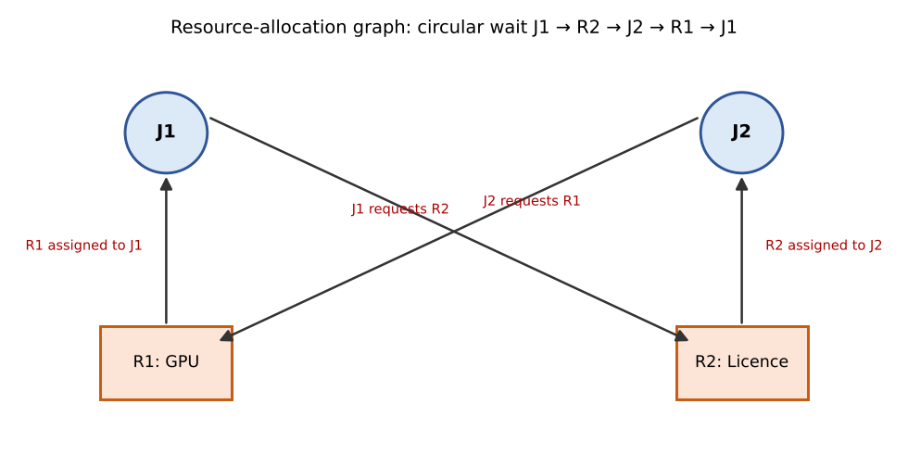
Figure 3 – Resource-allocation graph with a cycle: J1 → R2 → J2 → R1 → J1 (each resource has one instance, so the cycle means deadlock)
Request edges point from a job to a resource (J1 → R2, J2 → R1) and assignment edges from a resource to a job (R1 → J1, R2 → J2). All four conditions hold at the same time; removing any one of them prevents deadlock.

Complete the Code – TODO 1 (safety algorithm)
int ok = 1;
for (int r = 0; r < R; r++)
if (maxm[p][r] - alloc[p][r] > work[r]) { ok = 0; break; } /* need > work */
if (ok) {
for (int r = 0; r < R; r++) work[r] += alloc[p][r]; /* p finishes, returns resources */
finish[p] = 1; seq[count++] = p; found = 1;
}
initial state safe: P1 P3 P4 P0 P2
P1 request: granted, safe sequence P1 P3 P4 P0 P2
P4 request: must wait (not available)
P0 request: denied (unsafe)
Output matches the expected output.

Hand verification of the safe sequence and of P0's request
Need = Max − Allocation: P0 (7,4,3), P1 (1,2,2), P2 (6,0,0), P3 (0,1,1), P4 (4,3,1); Available = (3,3,2). Work = (3,3,2): P1 can finish → (5,3,2); P3 → (7,4,3); P4 → (7,4,5); P0 → (7,5,5); P2 → (10,5,7). Safe sequence P1, P3, P4, P0, P2 – as printed.
After P1's request (1,0,2) is granted: Available = (2,3,0), Allocation of P1 = (3,0,2). P4's request (3,3,0): 3 > available 2 in the first resource → must wait.
P0's request (0,2,0): (0,2,0) ≤ Need P0 (7,4,3) and ≤ Available (2,3,0), so pretend to grant: Available = (2,1,0); Allocation P0 = (0,3,0); Need P0 = (7,2,3). Needs now: P1 (0,2,0), P2 (6,0,0), P3 (0,1,1), P4 (4,3,1). With Work = (2,1,0): P1 needs 2 of the second resource but only 1 is free ✗; P2 needs 6 of the first ✗; P3 needs 1 of the third but 0 is free ✗; P4 needs 4 of the first ✗; P0 needs 7 ✗. No process can finish, so the state is unsafe and the request is denied (rolled back). The state is not yet deadlocked – it is only that deadlock can no longer be ruled out.
Alternative Concept and Complexity Analysis – detection and recovery instead of the Banker's algorithm
Criterion | Banker's algorithm (avoidance) | Detection and recovery
Time per request | A safety check on every request: O(m × n²) (n processes, m resource types) | None on the request path (grant if free): O(m)
Cost of detection | Included in every request | Detection algorithm (same O(m × n²)) every few minutes: amortised cost per request ≈ 0; deadlock may exist for minutes before it is found (idle GPUs)
Work lost | None – deadlock never occurs; some requests are delayed | A job is aborted (or rolled back) – all computation since its last checkpoint is lost, possibly hours; repeat deadlocks possible
Information needed | Maximum demand of every job in advance | None

B. Compare the strategies (3 marks)
Strategy | How | Strengths | Weaknesses for the cluster
Prevention | Remove one condition: e.g., request all resources at once (no hold-and-wait), or number resources and request in order (no circular wait) | Simple, no run-time checks, guarantee | Low utilisation (GPUs held idle while the licence is waited for); ordering hard to impose on all users
Avoidance (Banker's) | Grant a request only if the state stays safe | Highest utilisation of the safe strategies; no aborts | Needs maximum demands in advance, fixed number of resources and processes; O(m n²) per request; conservative
Detection and recovery | Allow deadlock; periodically look for a cycle; abort or roll back jobs | No advance knowledge; no overhead on requests | Lost work; cluster stops until detected; recovery policy (which victim) needed
Ignore (ostrich) | Assume deadlock is rare | Zero cost; used by Linux/Windows for user resources | Unacceptable here: deadlocks already happen and the whole cluster stops until the administrator intervenes

C. Apply the Banker's algorithm (4 marks)
The safety algorithm and the resource-request algorithm were implemented as in the program above (file banker.c; compiled with -std=c11 -Wall -Wextra, no warnings):
- Safety algorithm: Work = Available; repeat: find an unfinished process whose Need ≤ Work, add its Allocation to Work and mark it finished; if none can be found, the state is safe only if all are finished.
- Resource-request algorithm: if Request > Need → error (exceeds maximum claim); if Request > Available → wait; otherwise pretend to allocate (Available −= Request, Allocation += Request, Need −= Request) and run the safety algorithm; if safe grant, else restore the old state and make the process wait.
Request | Decision | Reason
P1 (1,0,2) | Granted – safe sequence P1 P3 P4 P0 P2 | ≤ Need (1,2,2), ≤ Available (3,3,2); new state is safe
P4 (3,3,0) | Must wait | Available (2,3,0) < request in resource 0
P0 (0,2,0) | Denied – unsafe | Within need and available, but no process could finish afterwards (hand calculation above)

D. Predict before implementing (1 mark)
Prediction: the safety algorithm scans up to n processes in each of up to n passes and compares m resources per process, so the worst case is O(m × n²); if processes finish in scan order (best case) it needs one pass: O(m × n). With m fixed at 3, time should grow ≈ 100× when n grows 10× in the worst case, and ≈ 10× in the best case.

E. Measure (1 mark)
Average time of one safety check (compiled with -O2, m = 3). Two cases: a random state in which processes finish early in the first pass (typical), and a constructed worst case in which only the last process can finish first, then the one before it, and so on (n passes).
n | Random state (µs) | Worst case (µs) | Worst-case growth | Prediction O(n²) for worst case
10 | 0.09 | 0.12 | – | –
100 | 0.64 | 8.41 | × 70 | × 100
1,000 | 6.08 | 597.5 | × 71 | × 100
3,000 | 19.9 | 5,184 | × 8.7 (from n = 1,000) | × 9
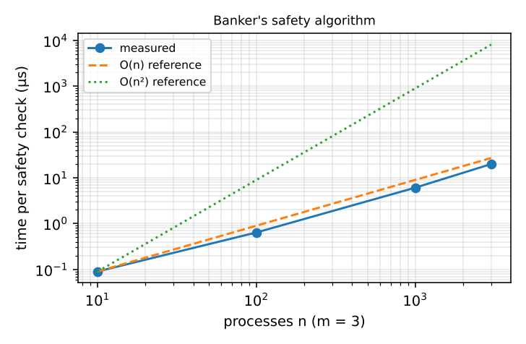
Figure 4 – Time of one safety check against n (random state; reference lines O(n) and O(n²))
Comparison: the random-state curve follows O(n) (×7–10 per 10× increase) – the first pass already finds most processes. The constructed worst case follows O(n²) (×70 per 10× from n = 10 to 100 and from 100 to 1,000, ×8.7 for 3× from 1,000 to 3,000, against predicted ×100 and ×9); the factor below 100 is due to cache effects and fixed per-call overhead for small n. The prediction O(m × n²) for the worst case is confirmed, and the best case O(m × n) is also confirmed.

F. Defend the final design (2 marks)
Recommendation: avoidance by the cluster scheduler, using the Banker's algorithm over the GPUs, licences and storage bandwidth, with detection as a safety net. Jobs submitted to a batch scheduler already declare their resource needs; the scheduler grants a request only if the state remains safe, so deadlock cannot occur and no work is lost.

Cost is small: the check costs ≈ 0.6 ms at n = 1,000 jobs even in the constructed worst case (5 ms at n = 3,000) – negligible against jobs that run for hours. The scheduler checks only when a job asks for resources, not on every instruction.
- Why not detection and recovery: aborting a long simulation wastes hours of GPU time; and between the deadlock and its detection the resources are idle.
- Why not prevention alone: requesting everything at once would leave expensive GPUs idle while jobs wait for a licence; but 'all-or-nothing' allocation is a useful simple fallback for small jobs.
- Why not ignore: the cluster already stops until an administrator intervenes.
Limitations: the Banker's algorithm needs the maximum demand declared in advance – users who overstate it lower utilisation (it is conservative), and users who understate it break the guarantee, so the scheduler must kill a job that exceeds its declared maximum. It also assumes a fixed set of resources and a fixed number of jobs; in a changing cluster the tables must be updated whenever a GPU is added or removed. Therefore a timeout-based detector (run every few minutes) is kept as a second line of defence.

MARK DISTRIBUTION
Question | Assessed Area | Bloom’s Level | Marks
Q1 | Processes and process states | K5 – Evaluate | 6
Q2 | CPU scheduling | K5 – Evaluate | 8
Q3 | Threads | K5 – Evaluate | 6

Question | Assessed Area | Bloom’s Level | Marks
Q4 | Inter-process communication | K5 – Evaluate | 6
Q5 | Synchronisation: critical sections, semaphores and monitors | K5 – Evaluate | 11
Q6 | Day-4 Design Challenge – Deadlock handling and Banker’s algorithm | K5 – Evaluate | 13
 | TOTAL |  | 50

Submission Requirements
GitHub repository link (mandatory) containing the executed code for every task, including every completed “Complete the Code” program, script and configuration file, with input files, output screenshots and a README.md.
- Your assignment report containing the required evidence for Q1–Q6
- C source code for all programs
- Gantt charts, diagrams, outputs and timings used as evidence

Assessment Verification
Students may be asked to explain any part of their design, code, calculations or results during a brief verification discussion/viva.
Overall Assessment Expectation
Model → Design → Implement → Measure → Compare → Evaluate → Recommend

